Batch: A1 Roll No.: 16010123012
Experiment No. AWS 4
Grade: AA / AB / BB / BC / CC / CD /DD

Title: Host a Static Website using Amazon S3
Objective:
- Create an S3 bucket
- Upload a static website file
- Enable static website hosting
- Configure public access using a bucket policy
- Access the hosted website
Expected Outcome of Experiment:
CO | Outcome
CO5 | Configure and experiment with advanced cloud technologies
Books/ Journals/ Websites referred:
https://kjssecloudlab.somaiya.edu/lab-catalogue/CloudComputing_Lab4
Abstract:
This experiment demonstrates how to host a static website using Amazon S3. It involves creating an S3 bucket, uploading a basic HTML file, enabling static website hosting, and configuring public access using a bucket policy. The hosted website is then accessed through a generated endpoint URL. This experiment highlights how cloud storage services can be used to deploy simple websites without requiring traditional web servers.
Related Theory:
Amazon S3 (Simple Storage Service) is a scalable object storage service used to store and retrieve data. It can also be used to host static websites consisting of HTML, CSS, and JavaScript files. Static website hosting allows users to serve web content directly from an S3 bucket. By enabling this feature and specifying an index document, the bucket acts like a web server. A bucket policy is used to control access permissions. In this experiment, a public read policy is applied so that anyone can access the website content. This setup follows a serverless architecture, where no backend server is required, making it cost-effective, scalable, and easy to manage.
Implementation Details:
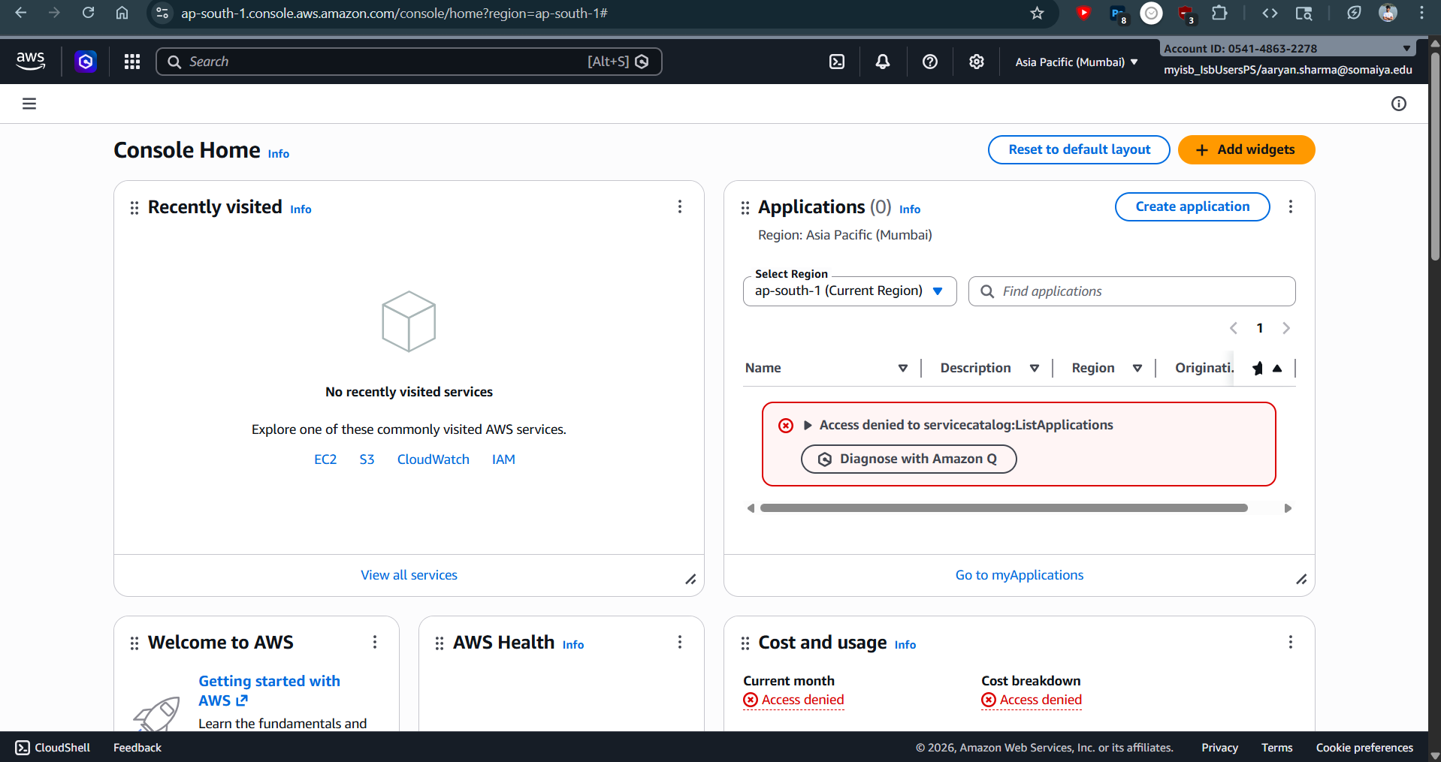
Opening Amazon S3
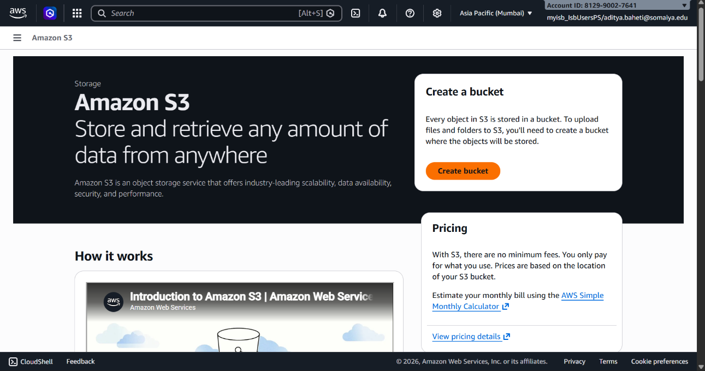
Creating a Bucket
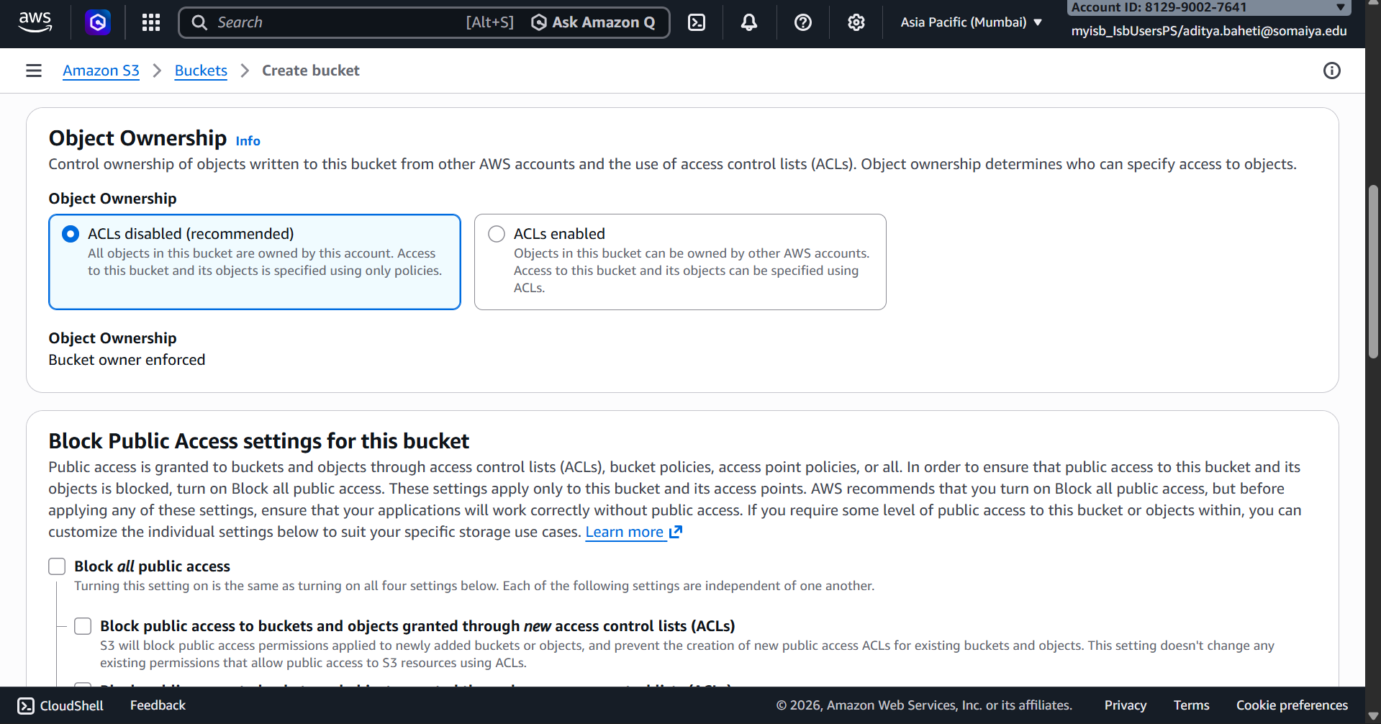
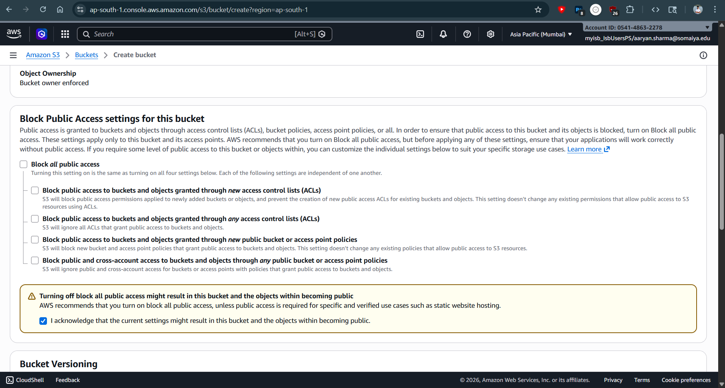
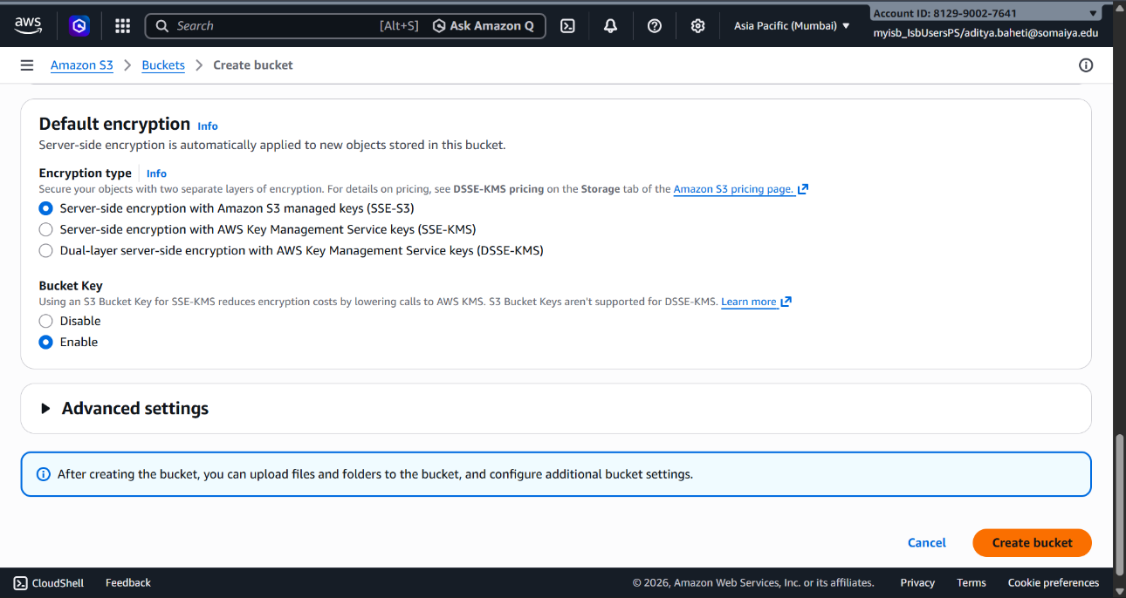
Configuring the Bucket
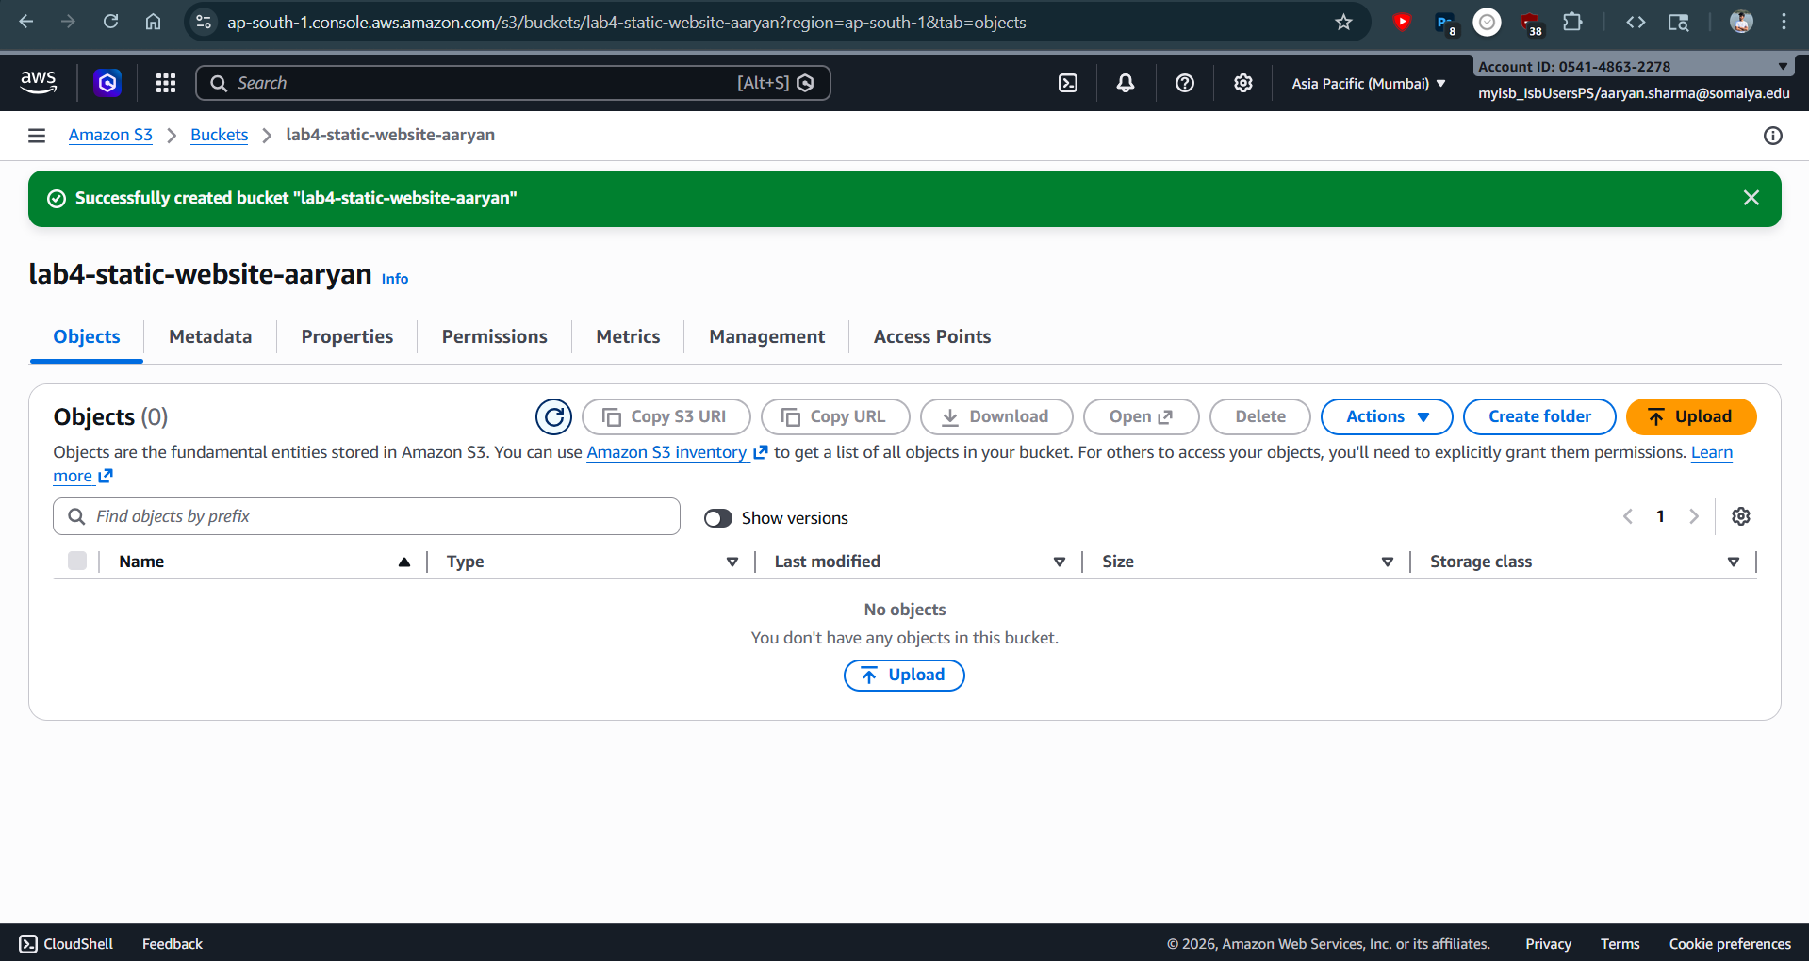
Successfully creating the bucket
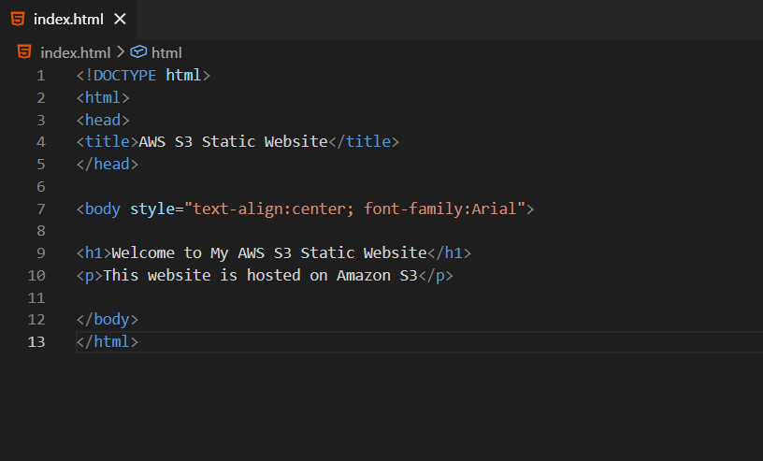
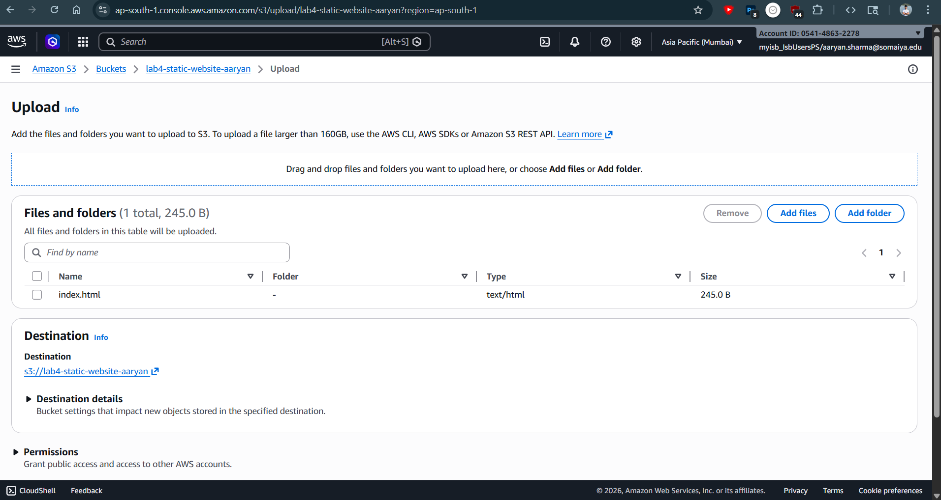
Uploading index.html
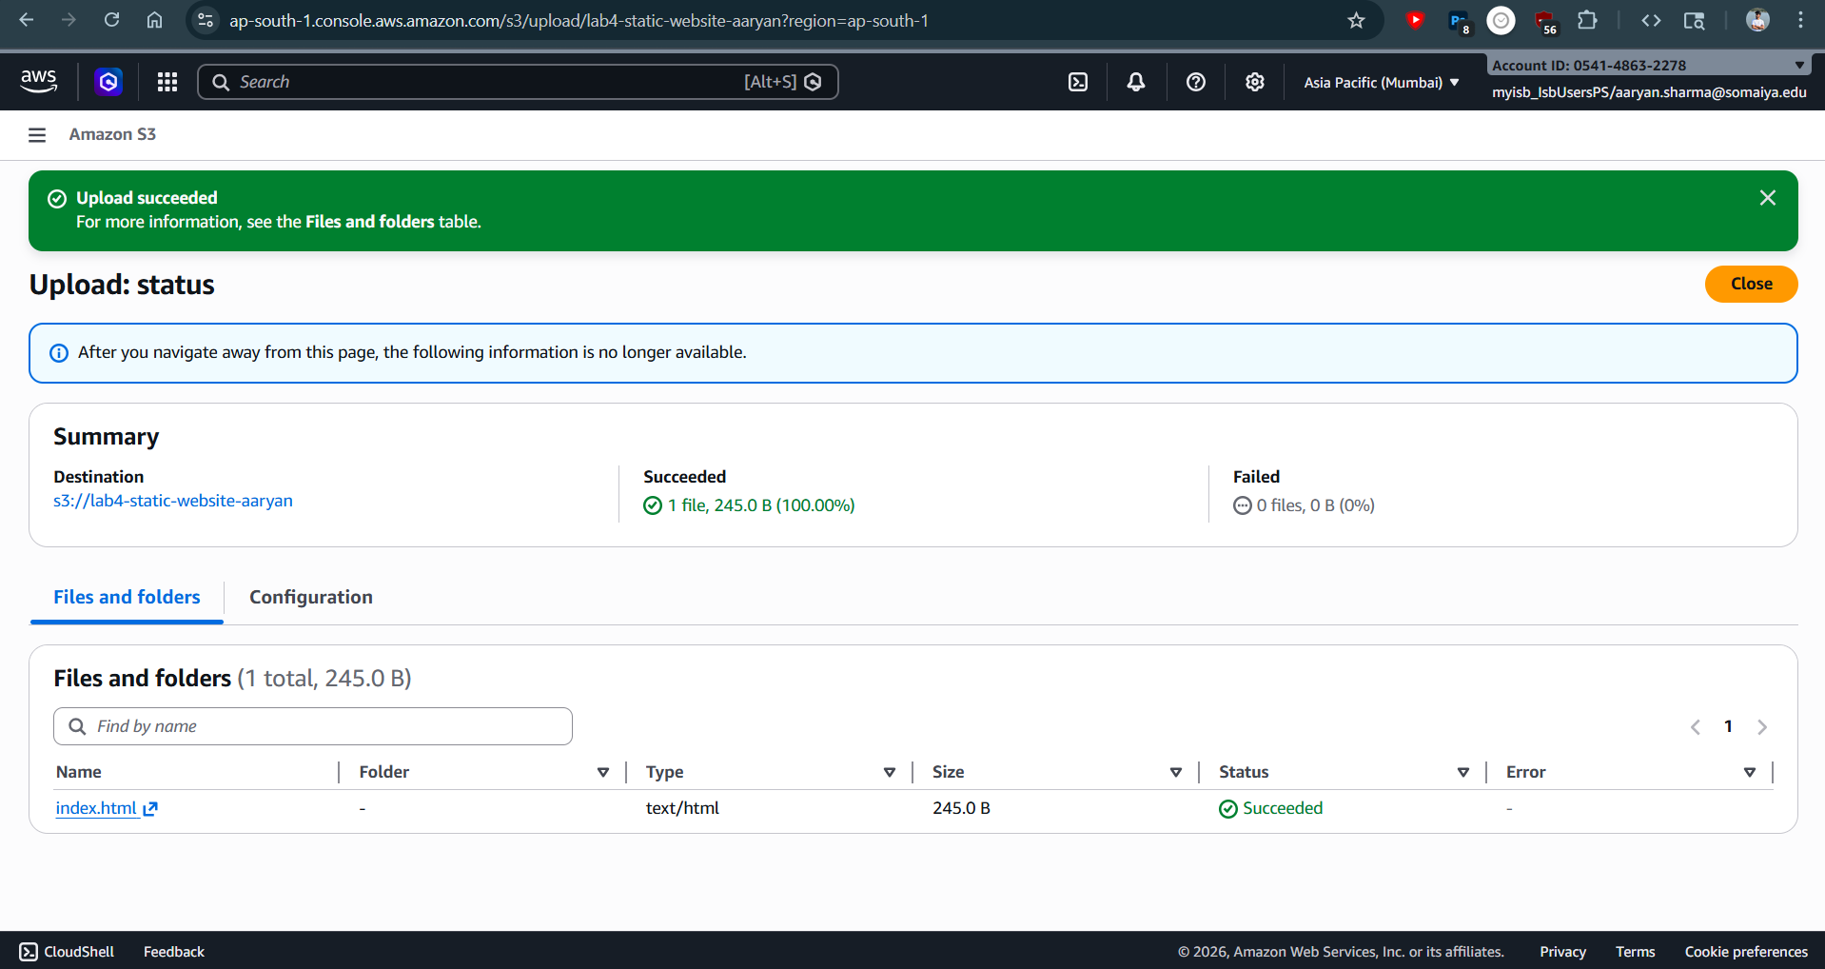
Successfully uploaded index.html
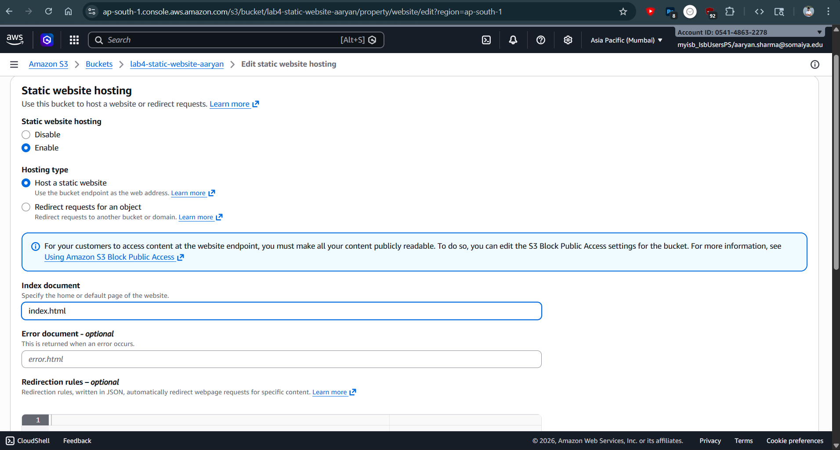
Enabling Website Hosting
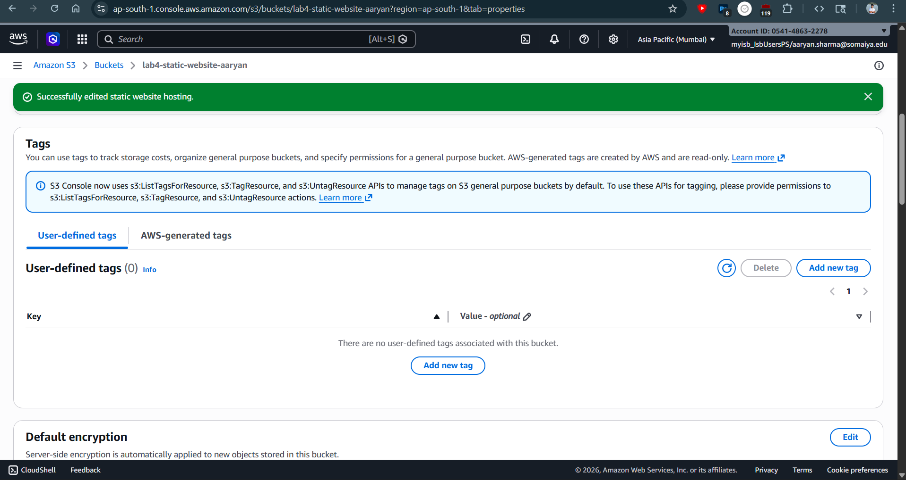
Successfully enabling website hosting
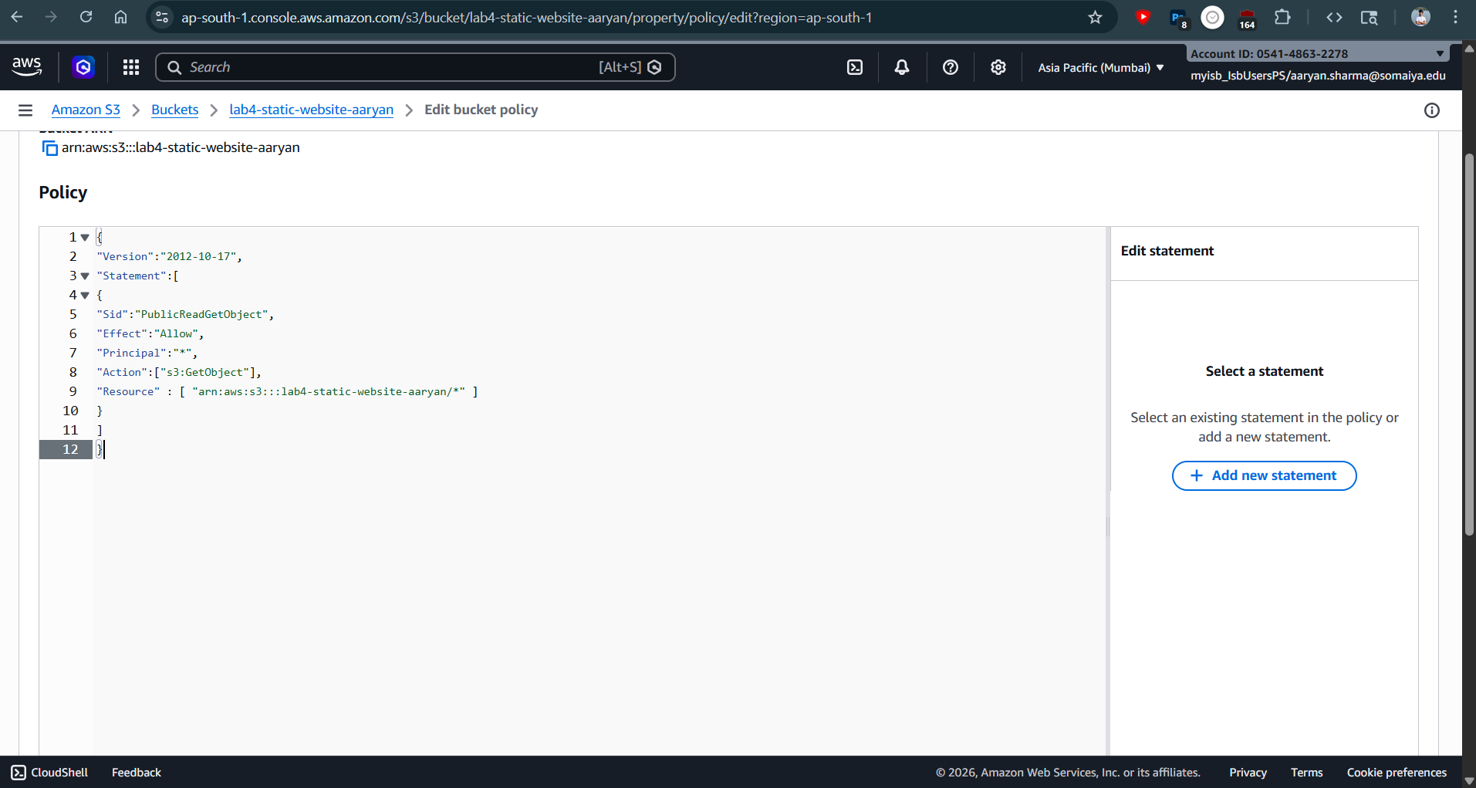
Adding Public Access Policy
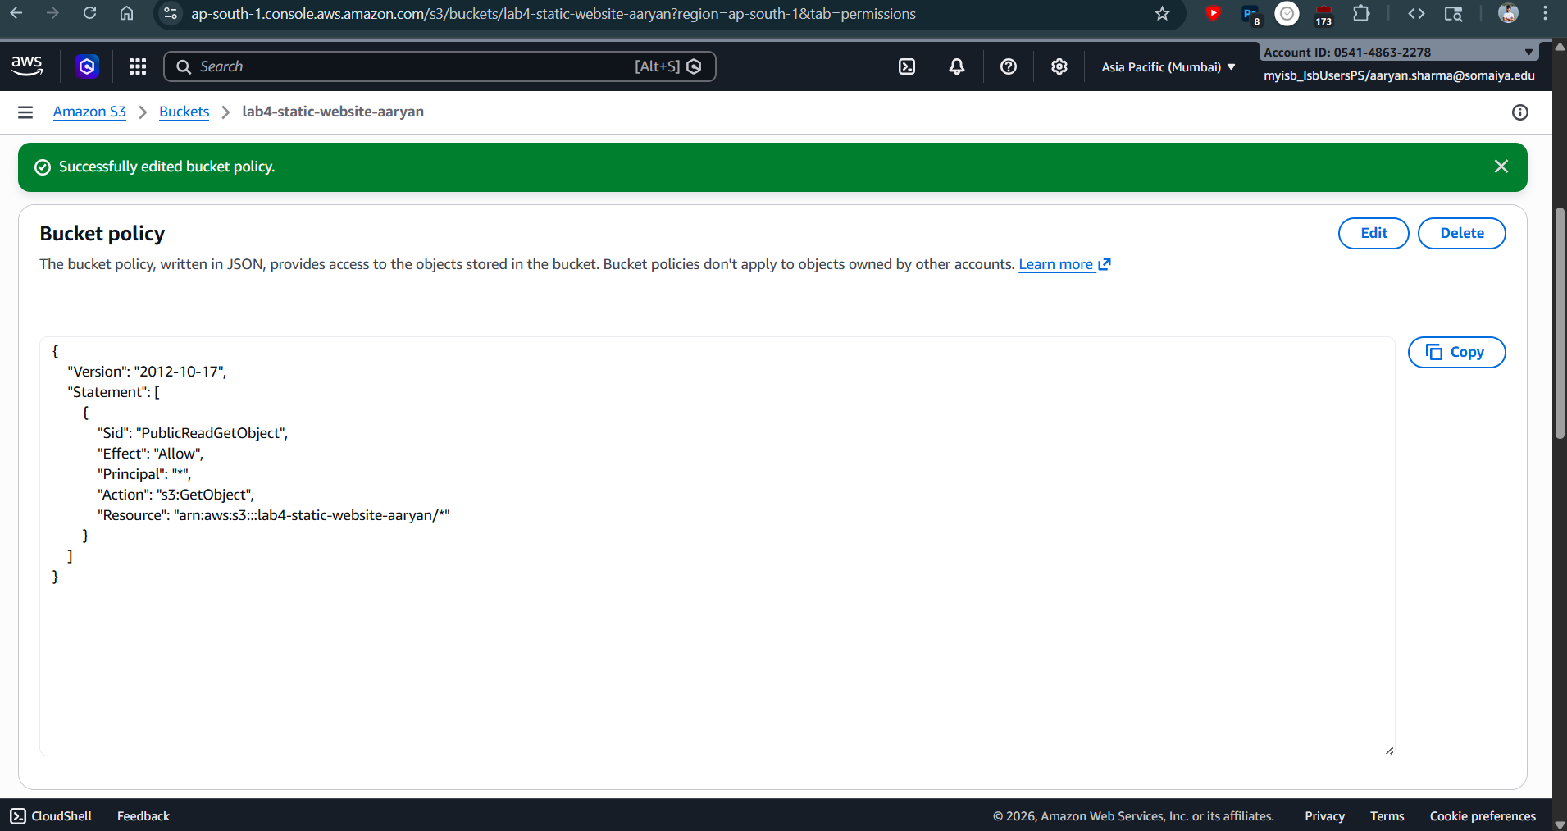
Successfully added Public access Policy
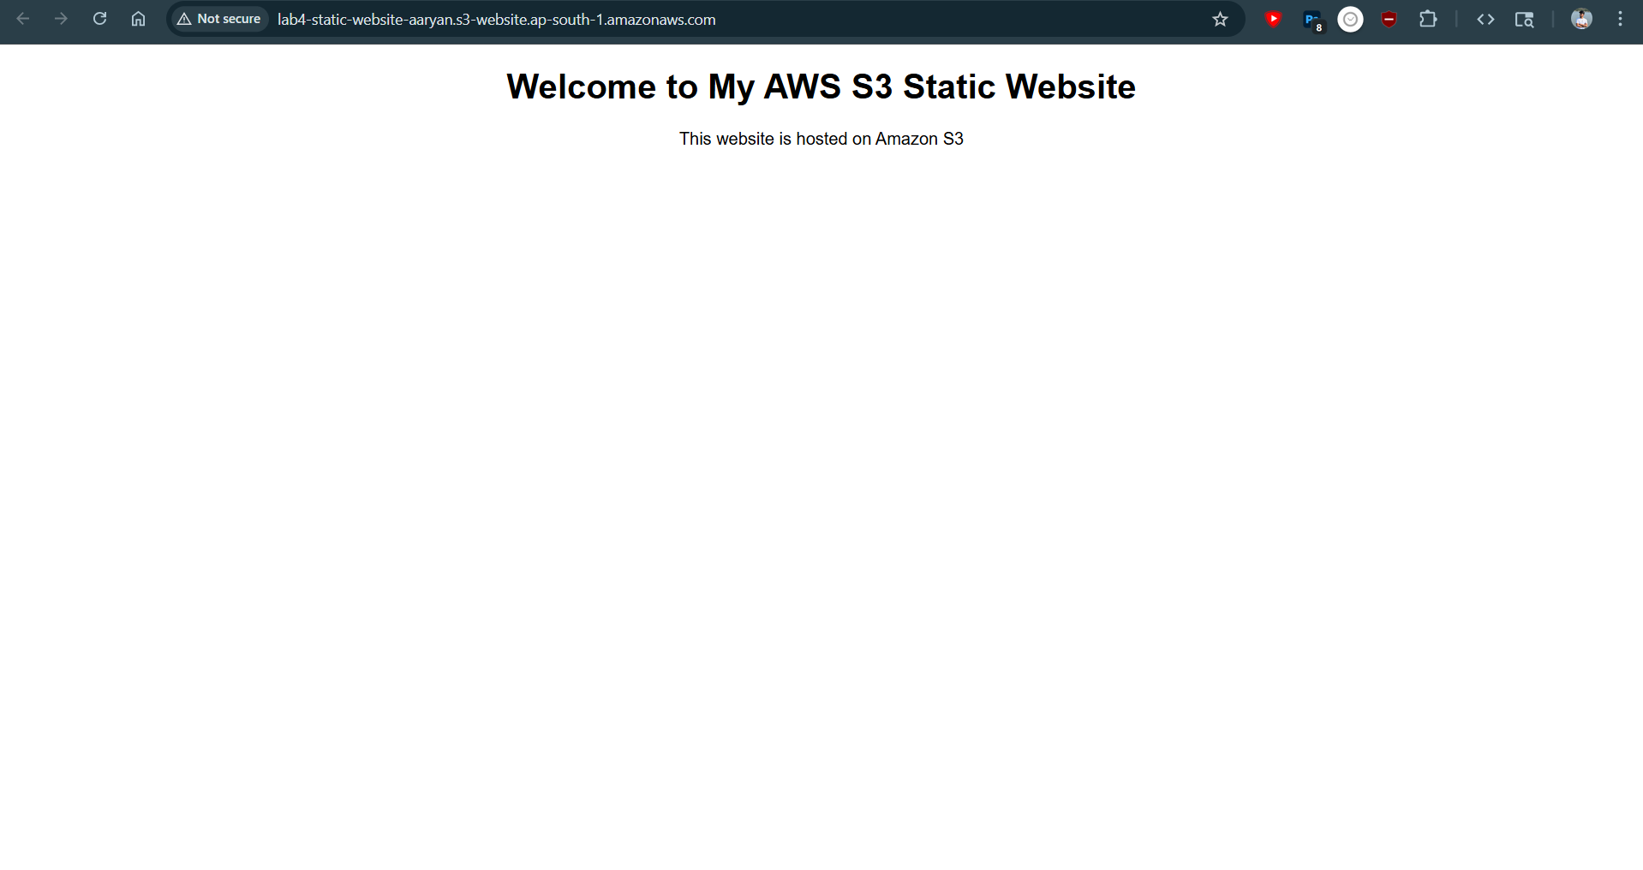
Successfully hosted the website
Conclusion:
In this experiment, a static website was successfully hosted using Amazon S3. A bucket was created and configured with appropriate settings, and an HTML file was uploaded as the website content. Static website hosting was enabled, and a public access policy was applied to allow users to access the website over the internet. The hosted website was successfully accessed using the generated endpoint URL. This experiment demonstrated how Amazon S3 can be used as a serverless platform for hosting static web content, highlighting its scalability, cost-effectiveness, and ease of deployment in cloud environments.

